
Worcester Polytechnic Institute

Robotics Engineering Program

Lab 4: Localization

Submitted By
Alex Henning
Jeffrey Orszulak

Julien Van Wambeke-Long

Date Submitted: April 9, 2013

Date Completed: April 9, 2013

Course Instructor: Prof. Chernova

Abstract
The lab exercise described and discussed below emphasizes techniques used for reading laser scan data and interpreting it to generate a local occupancy grid which can in tern be used to localize the robot in a given global map. The ability to edit the global map with new obstacles as detected by the robot is also explored.

Introduction
In lab 4 an emphasis was placed on the ability to read the Kinect sensor attached to the turtlebot and generate a local occupancy grid based upon the reading provided from the sensor. The grid generated was compared against a map of a known environment to determine what location and orientation on the global map is the best fit for the robot’s field of vision. Finally, given a position on the global map, the robot was tasked to take in Kinect data and based on its known location recognize and add an obstacle to the global map.

Methodology
Lab 4 can be divided into two main parts: localization and registration. Localization encompasses generating an occupancy grid and comparing it to a known map with the same grid size to determine what location and orientation has the most overlap between the grids. Registration uses the same grid generated for localization, but uses given information about its current location to map new obstacles into the global map.
The ability to visualize an occupancy grid is essential to the success of this lab exercise so this served as a natural starting point. Before a local grid can be generated, the provided global map needed to be scaled down to a size that would allow later algorithms to run through each cell of the map at different positions and orientations in in reasonable amount of time. A scale factor of 19.8 was used to keep near rounding error down and resulted in a map with dimension 20 by 27. An occupancy grid consists of map info, such as the length and width of the map as its resolution, and metadata, which is an array of integers from -1 to 100 representing the probability that the space is occupied; higher values represent higher probabilities and a value of -1 is used in cells without any known data. To begin, an empty occupancy grid is generated with dimensions similar to that of the global map, 20 by 27. All the entries in the map are set to -1, meaning nothing is known about the robot’s surroundings. When the scan topic in ROS is updated, a function is called to update the local map with the Kinect data. Since the data received is a list of distances separated by a given angle reading, trigonometry is used to determine where on the local map each provided point is. By setting the corresponding element of the occupancy grid to 100, the wall of the local are created. After entering the Kinect data, lines are drawn from the origin of the local map (where the robot is located) to the walls and all grid cells on the line are set to 0, showing that area is known open space.
To localize the robot, the local grid and global grid are compared, setting the origin of the local map to each open cell in the global map. The cells of the maps are then compared by taking the absolute value of the difference between the global cell from the local cell. This value is then normalized to a scale of 1 to 100, by dividing by the number of cells compared with lowest values being the closest matches. This process is looped for all cells of both maps, and the lowest current value is tracked, then returned at the end of the program with the corresponding x and y points on the global gird and an angle value representing the rotation of the robot.
Registration uses the same occupancy grid generation but rather than cycle through each possible location on the global grid, a location is provided to the robot. The robot compares the grid it sees to the global map and determines differences. The local grid is averaged with the global grid to where it overlaps. This process does explicitly ignores initial walls and allows for occupancy probabilities to change over time.

Results and Discussion
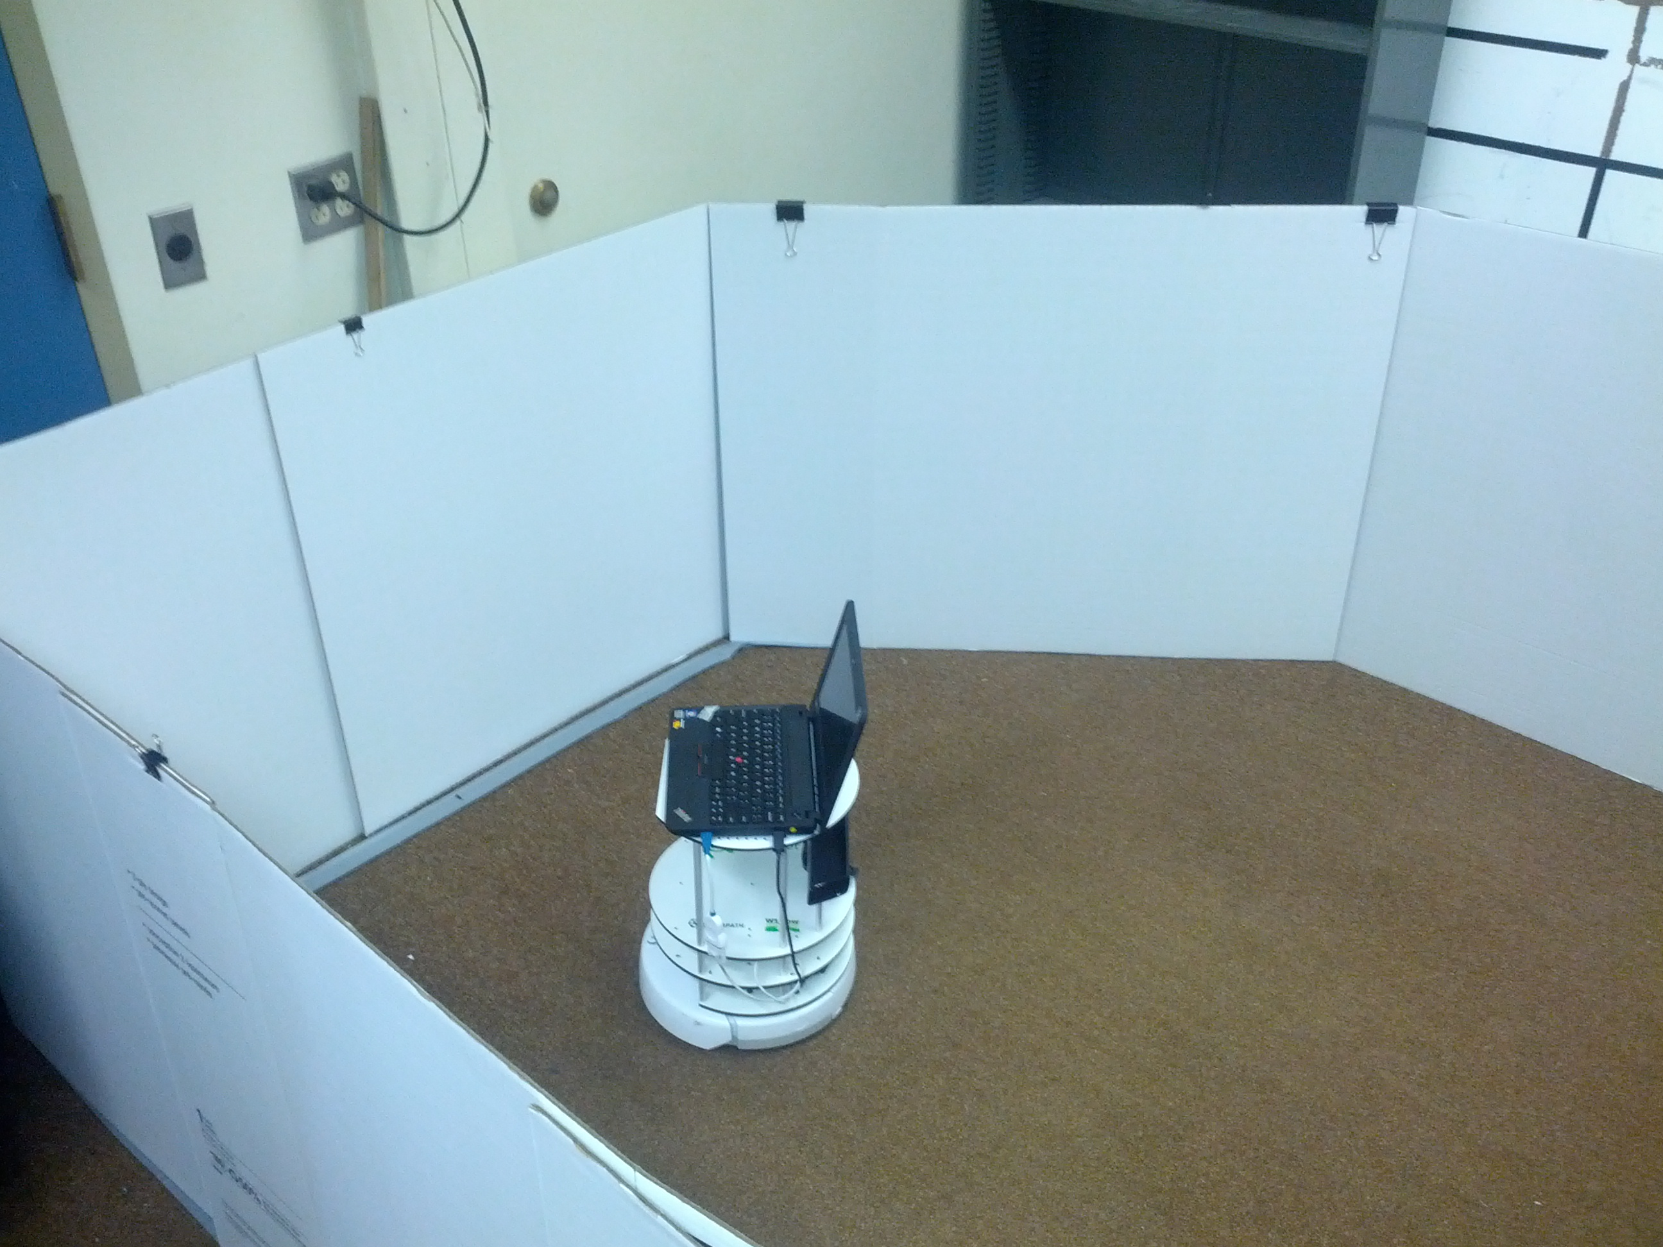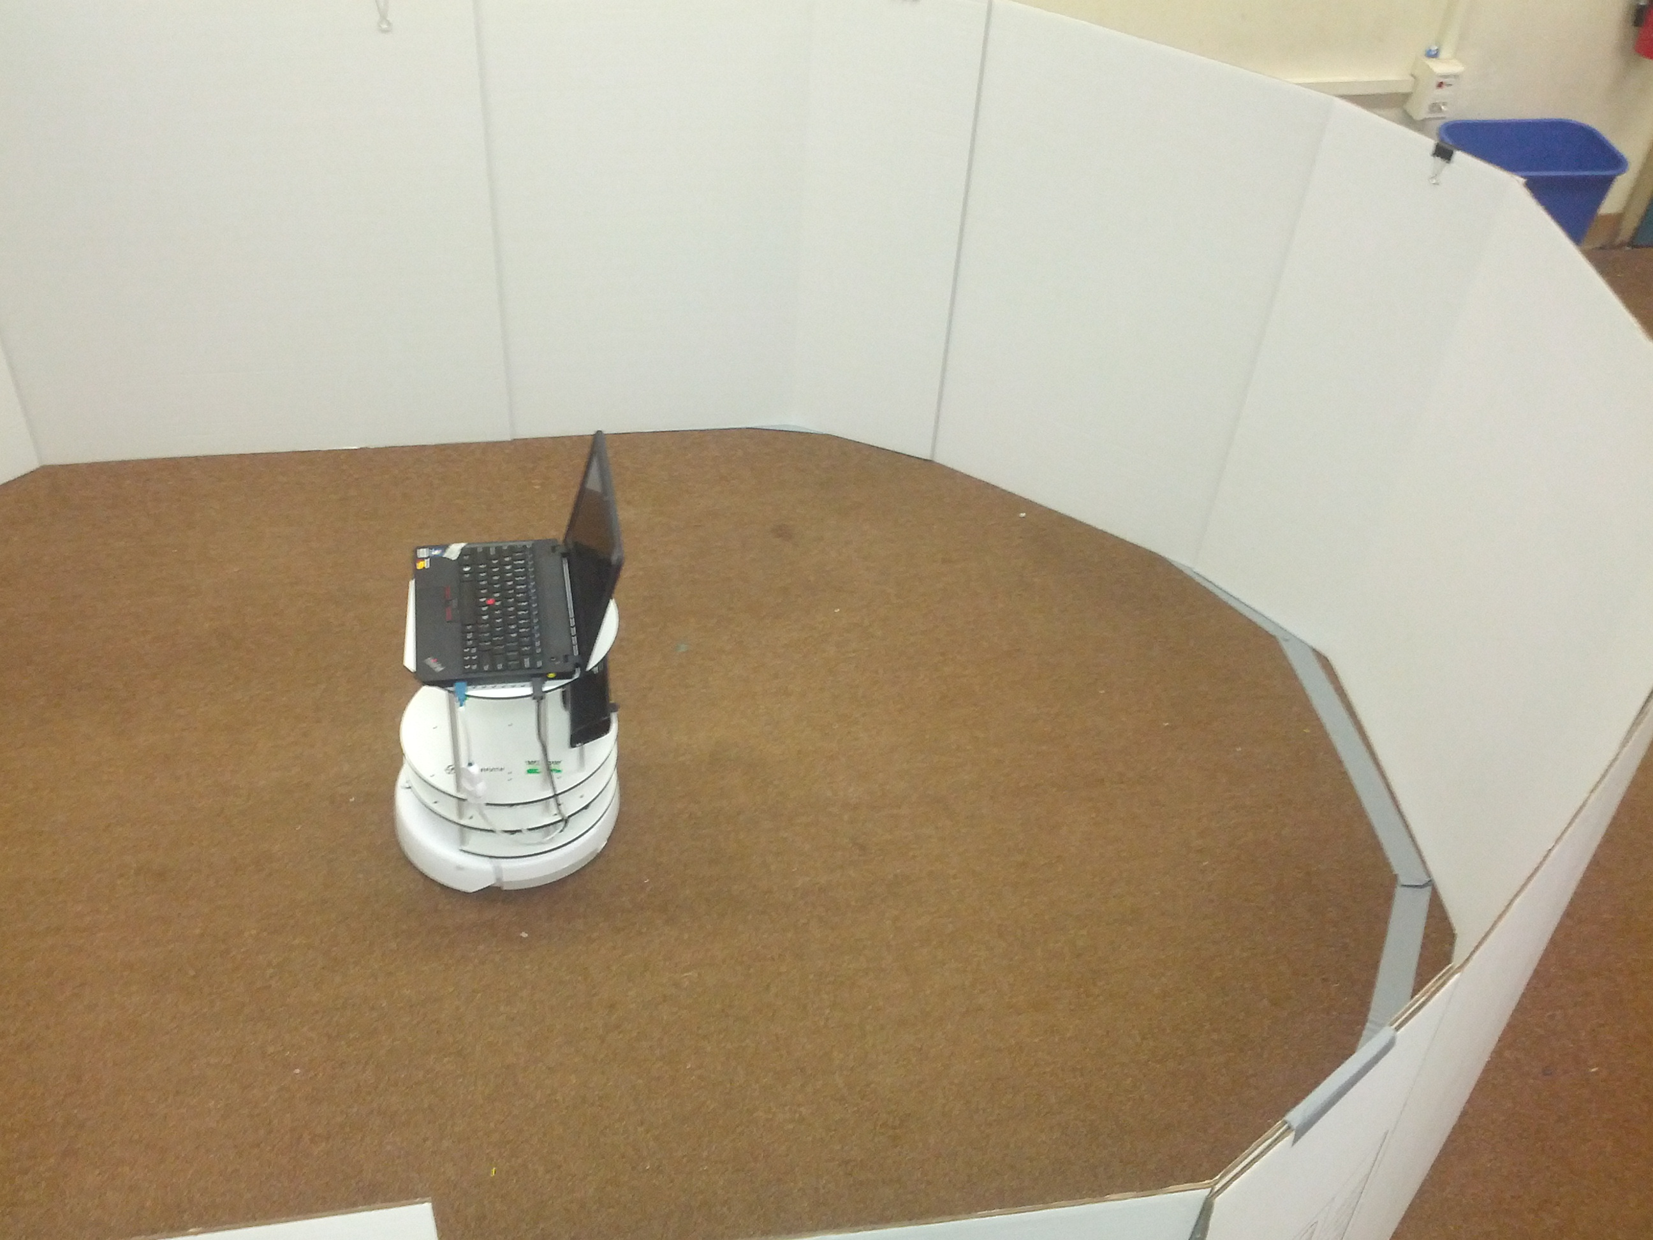
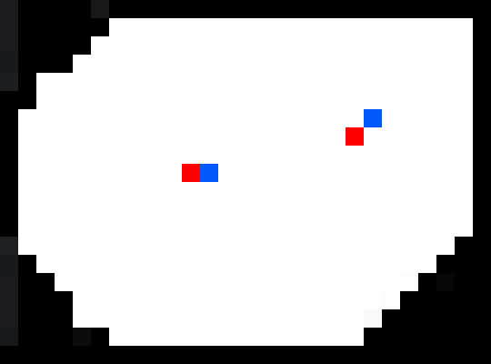
The resolution of the global map is a large factor in the time required to run the localization algorithm. By scaling back the map, the time required for the algorithm to run decreases significantly. After initially scaling it down by a factor of 10, we settled on about 1/20th the initial resolution which still resulted in two minute run-times. In the figures above, the red dot indicates the robot’s calculated position after two localization attempts. The blue dot represents the orientation of the robot. Comparing these dots to the two figures above shows the accuracy of our algorithm. The total run time for the algorithm is about 2 minutes, but this is for localization without any prior knowledge of the robot’s environment. In future applications, the robot will have an idea of where it is, so is only required to check gird cells around the location it thinks it is.
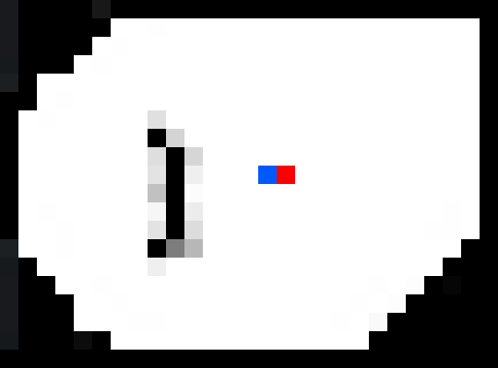
The figure above shows the robot registering objects into the global map. The red dot once again represents the location of the robot with the blue dot representing the front. Varying shades of gray show the gradual buildup of the object in the map to eliminate false sensor readings. The dark black represents the certainty that the object is present. By using the average values of the old and new cells when calculating the map update, new elements appear fairly quickly and fade with time if they are no longer seen. Additionally, only the cells that overlap the local grid are updated, so obstacles found in other parts of the map do not fade when the robot leaves the areas so can no longer see them. The algorithm also prevents the original walls of the map from being changed to prevent changes to the known global world by mistake.

Conclusion
Lab 4 demonstrated the steps needed to localize a robot in a completely unknown environment, and the time necessary to run a localization algorithm. In application, this time decreases after an estimated position is determined, as only cells around that location will be tested which is far few calculations than comparing 2 girds without prior data. Additionally, the impact the resolution and the number of orientations tested have on the execution time were explored and optimizations, such as skipping unknown cells, were examined.

